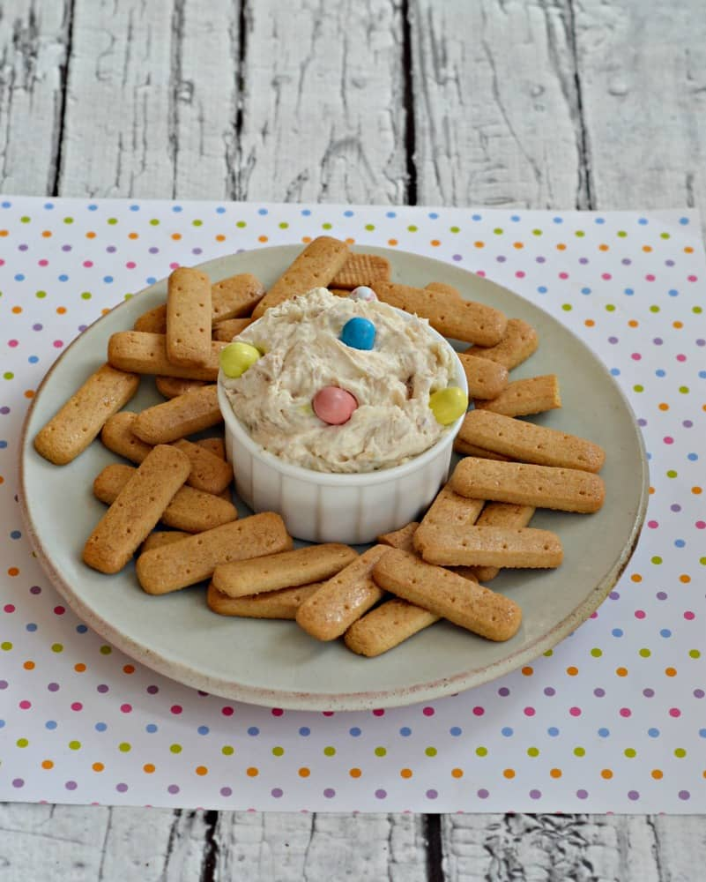
EASTER MALTED MILK DIP

INGREDIENTS
- 8 oz. cream cheese, softened
- 1 c. powdered sugar
- 1 t. vanilla
- ½ c. vanilla cookies, crushed
- ½ c. Easter malted milk balls, roughly chopped, plus addition for topping
- 1 c. heavy cream
- graham cracker sticks

INSTRUCTIONS
- In a large bowl combine the cream cheese, powdered sugar, vanilla, vanilla cookies, Easter malted milk balls, and heavy cream.
- Beat on medium speed with a mixer until well combined.
- Place in a bowl and top with Easter malted milk balls. Serve with graham cracker sticks.

